Tŷ Newydd Writing Centre
Bursary Application Pack
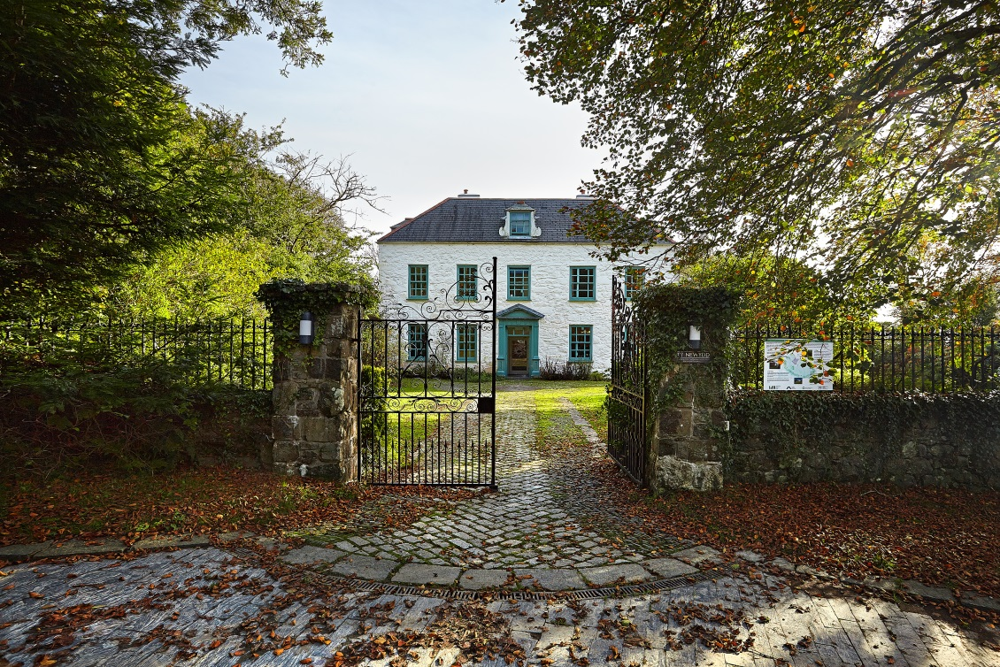
Literature Wales aims to enable everybody who would benefit from a course at Tŷ Newydd to do so, regardless of income or level of experience. We have bursaries available for individuals who might need financial help; however, funds are limited. Therefore, before applying for a bursary, please consider:

- Sharing a room – this option can be up to £130 cheaper than single rooms
- Paying for your course fee in instalments of up to 12 months, except for the £100 non-refundable deposit required on booking
If the course fee still makes it difficult for you to attend, then you may be eligible to apply for a bursary of between £50 - £200. To do so, please complete the form below, and attach the relevant supporting documents. Please note that you will need to request financial assistance before booking a course. Bursary requests cannot be considered after a booking has been made.

While we prioritise people on lower incomes, we cannot always guarantee financial assistance.

How Bursaries are funded
Fundraising for bursaries is ongoing through various events and activities. Generous donations and contributions from visitors and friends are gratefully received throughout the year. If you would like to donate to the bursary fund, please contact Literature Wales:
01766 522 811 / tynewydd@literaturewales.org

How to apply for a bursary
- Read the notes on the next page in detail. Ensure that the criteria are applicable to you, and that you agree with the terms and conditions
- Fill in the application form and the personal statement and send both, along with all relevant documents, to tynewydd@literaturewales.org or to: Bursaries, Tŷ Newydd Writing Centre, Llanystumdwy, Cricieth, Gwynedd, LL52 0LW
- A provisional place on a course will be reserved for you whilst your application is being assessed
- Literature Wales staff will regularly assess the applications received. Applicants will be informed of the decision within a month of submission
- If your application is successful, a non-refundable deposit of £100 will be requested within 7 days of confirmation of a bursary to confirm your place on the course
Notes
Criteria
Please note the following eligibility criteria:
- Applicants must be UK residents, and priority is given to residents in Wales
- Bursaries are restricted to one per person per year, and applicants who have not previously received a bursary will be prioritised
- Other priorities include those from a low-income household with no savings; individuals under 25; or those who receive disability benefits. To enable assessment, supporting documents must be presented with every application to demonstrate need
- A personal statement outlining how the course will help to develop the participant’s skills and career as a writer will also be taken into consideration
Supporting Documents
Please supply photocopies of the following documents to support your bursary application, if applicable. Documents will not be returned. Security details (e.g. bank account number) can be hidden, and all documents will be destroyed after the application process:
- Bank statements from the last three months
- A letter or official document verifying means-tested state benefits including Income Support, Working Tax Credit, Child Tax Credit, Universal Credit and Housing Benefit etc
- A letter or official document confirming Disability Living Allowance or Personal Independence Payment
Terms and conditions
- If your application is successful, please pay the non-refundable deposit of £100 within 7 days of confirmation of a bursary, to confirm your place on the course
- Bursaries do not contribute towards travel costs, and participants are encouraged to share lifts where possible
- You will be required to submit a written report within two weeks of the course ending. Literature Wales will provide a template. We reserve the right to use the report for future funding applications, and for testimonial purposes on our website and publications
- Bursaries awarded cannot be transferred to a different course. If a successful bursary applicant cannot attend the course, he/she will need to re-apply for a new bursary in any future courses
- We do not award bursaries for Retreats.
- Only one bursary can be offered for each Masterclass, which are awarded a few weeks prior to the course
- Decisions regarding bursary applications are final.
Application Form 2017
If filling in form by hand, please use capital letters
Name:

Address:

Email address:

Phone number:

Which course are you applying for?

Dates of the course:

Are you happy to share a room?

Have you been on a Tŷ Newydd course before?

If yes, which course and when?

Have you received a bursary from Tŷ Newydd before?

If yes, for which course and when?

How much financial assistance do you -require? (£50 - £200)

What is your annual household income?

What is your employment situation? E.g. are you unemployed, in full-time education, working freelance
Do you receive any benefits (including Disability Living Allowance or Personal Independence Payment)?

Do you have any savings?

I attach supporting documents to support my bursary application (please tick)
Proceed to next page for the Personal Statement.
Personal Statement
In this section (or in a separate letter) you should elaborate on the reasons you need to apply for financial support to attend the course. Please note why you wish to attend this particular course.
(Maximum 500 words)
I certify that the information provided is correct, and that I agree with the terms and conditions:

Signed........................................................ Date ..................................................

